Company Name | Click or tap here to enter text. |  | If acting on behalf of a customer & they want to have their name appear on the certificate
Address | Click or tap here to enter text. |  | Company Name | Click or tap here to enter text.
Address | Click or tap here to enter text. |  | Address | Click or tap here to enter text.
Telephone | Click or tap here to enter text. |  | Address | Click or tap here to enter text.
Email Address | Click or tap here to enter text. |  | Only available for UKAS calibrations
Contact Name | Click or tap here to enter text. |  | Improtant Note: If you know the price of the required service, please include a purchase order listing the items & prices - This will eliminate the need to send you a quotation & help us ensure the fastest and most efficient turnaround time
Purchase Order Ref: | Click or tap here to enter text.
Details about your equipment |  |  | Type of calibration Required |  |  | Direction Required |  |  | System Calibration |  |  | Customer Asset No.
Part No. | Click or tap here to enter text. |  | UKAS Calibration | ☐ |  | Clockwise | ☐ |  | Yes | ☐ |  | Click or tap here to enter text.
Serial No. | Click or tap here to enter text. |  | In-House Calibration | ☐ |  | Both Directions | ☐ |  | No | ☐
 |  |  | Only an option for TruCheck, Torque Wrench & Multipliers |  |  | Only available for UKAS calibrations |  |  | Only available for UKAS calibrations |  |  | Only available for UKAS calibrations
Part No. | Click or tap here to enter text. |  | UKAS Calibration | ☐ |  | Clockwise | ☐ |  | Yes | ☐ |  | Click or tap here to enter text.
Serial No. | Click or tap here to enter text. |  | Traceable Calibration | ☐ |  | Both Directions | ☐ |  | No | ☐
Part No. | Click or tap here to enter text. |  | UKAS Calibration | ☐ |  | Clockwise | ☐ |  | Yes | ☐ |  | Click or tap here to enter text.
Serial No. | Click or tap here to enter text. |  | Traceable Calibration | ☐ |  | Both Directions | ☐ |  | No | ☐
Part No. | Click or tap here to enter text. |  | UKAS Calibration | ☐ |  | Clockwise | ☐ |  | Yes | ☐ |  | Click or tap here to enter text.
Serial No. | Click or tap here to enter text. |  | Traceable Calibration | ☐ |  | Both Directions | ☐ |  | No | ☐
Part No. | Click or tap here to enter text. |  | UKAS Calibration | ☐ |  | Clockwise | ☐ |  | Yes | ☐ |  | Click or tap here to enter text.
Serial No. | Click or tap here to enter text. |  | Traceable Calibration | ☐ |  | Both Directions | ☐ |  | No | ☐
Any other requirements?
Click or tap here to enter text.

If you would like one of our Technical Sales Engineers to contact you to discuss your equipment, application, best practices, or other Norbar products, please tick the box. This ensures you receive expert, personalised support tailored to your operational needs.
☐ | Yes, please contact me using the above contact information

Next Steps
Please ensure your items are securely packaged and include a copy of the completed form. Return them to:
Norbar Torque Tools Ltd
Wildmere Road
Banbury
OX16 3JU

Kindly mark the package for the attention of the Aftersales Department to help us process your return promptly.

To ensure the safety and efficiency of our service and repair process, we kindly request that you do not return lithium batteries when sending your equipment to us for service or repair.
When preparing your equipment for shipment, please remove any lithium batteries and retain them for future use.
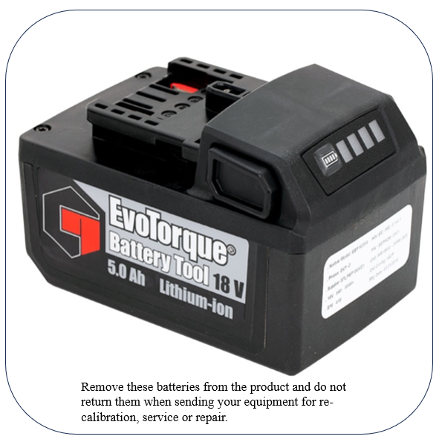
If lithium batteries are returned and deemed unsafe for return shipment, we reserve the right to refuse the shipment and dispose of them safely at your cost.



